# check register functionality

## user register with valid nama lengkap, email and password

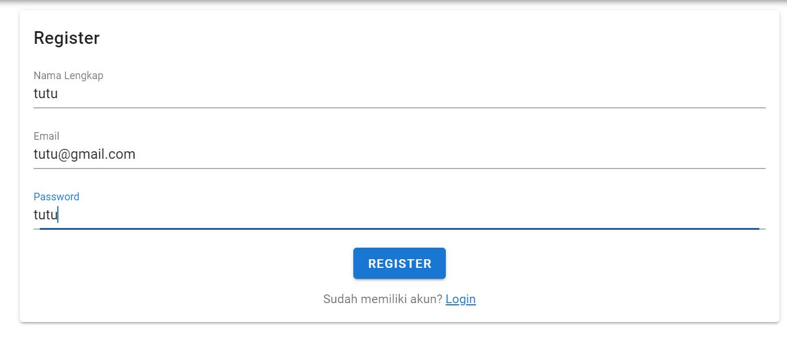

## user register with invalid nama lengkap, valid email and valid password

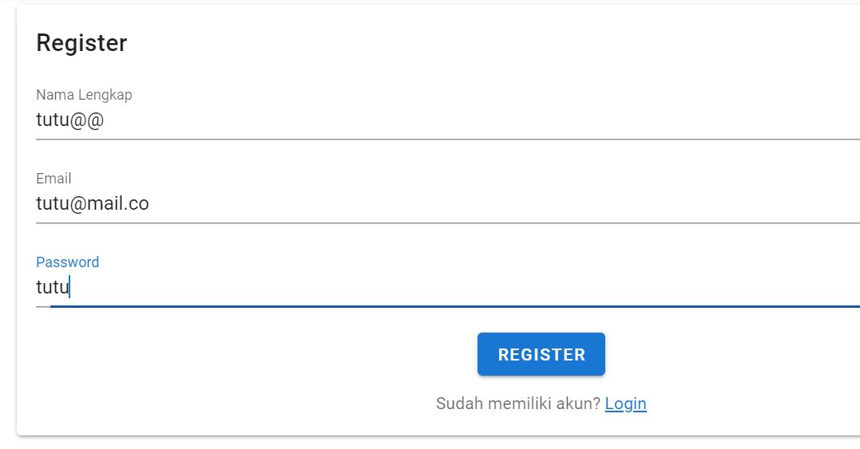

## user register with valid nama lengkap, invalid email and valid password

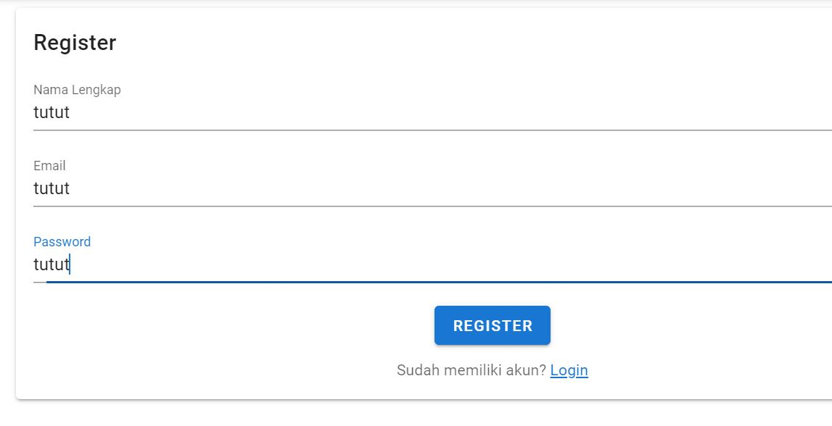

## user register with valid nama lengkap, valid email and invalid password

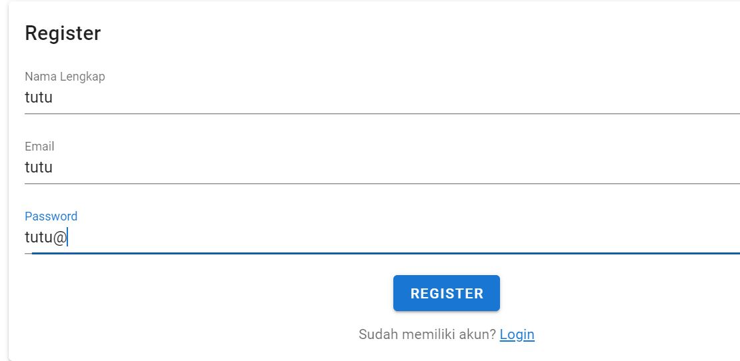

## user register with invalid nama lengkap, invalid email and invalid password

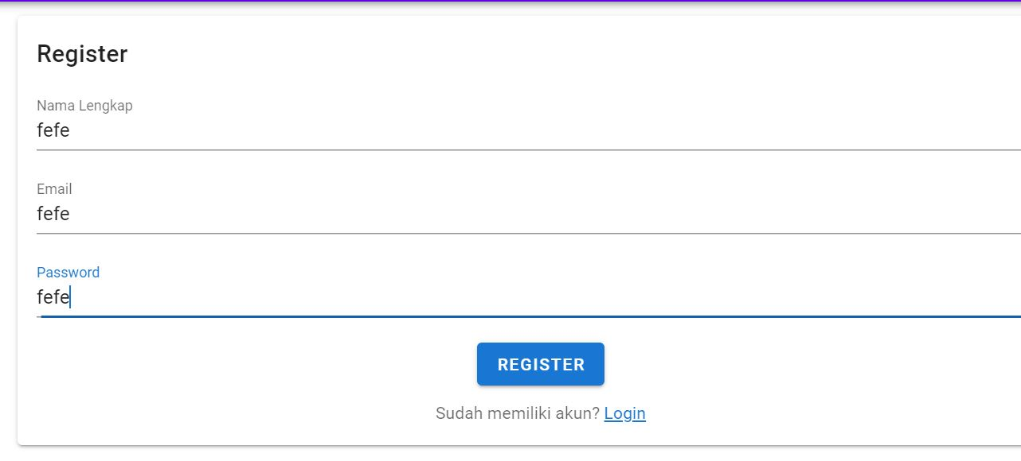

# check the login functionality

## user login with valid email and valid password

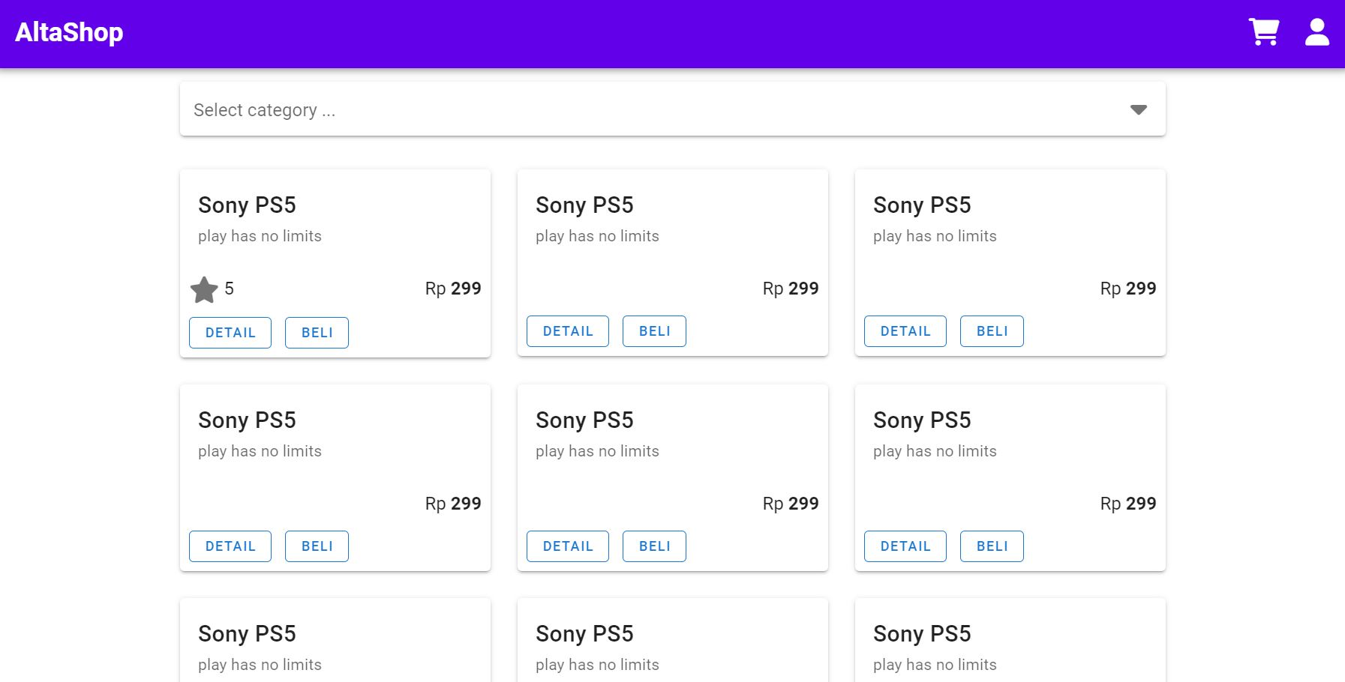

## user login with valid email and invalid password

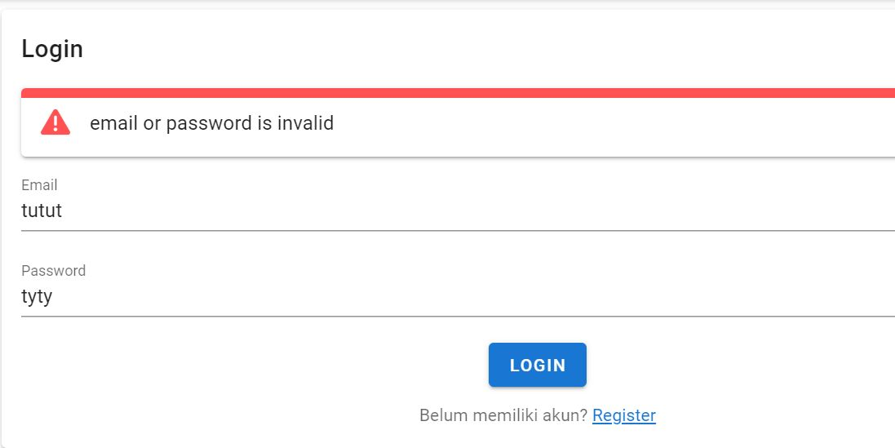

## user login with invalid email and valid password

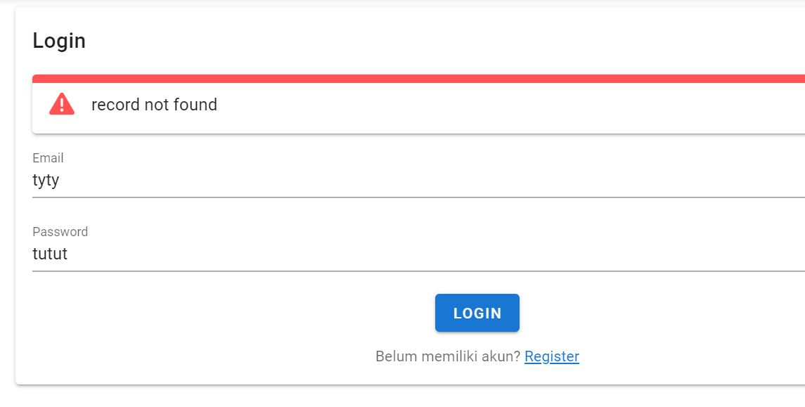

## user login with invalid email and invalid password

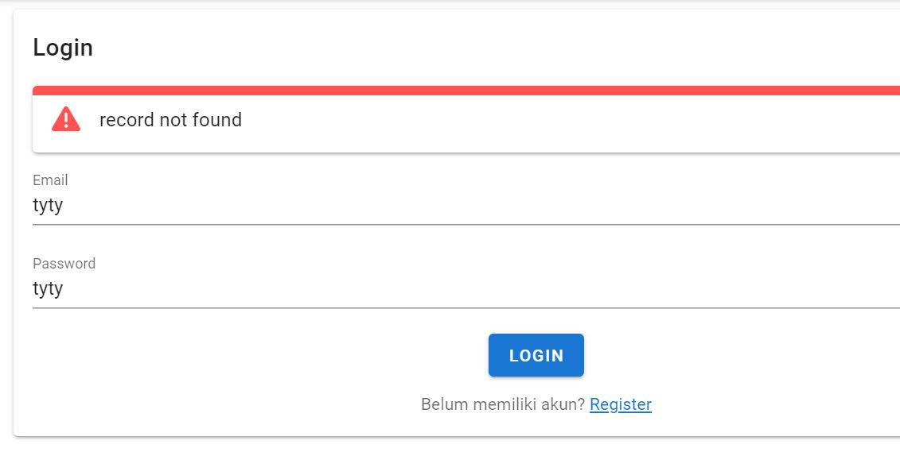

# check the category functionality

## user select 1 available category

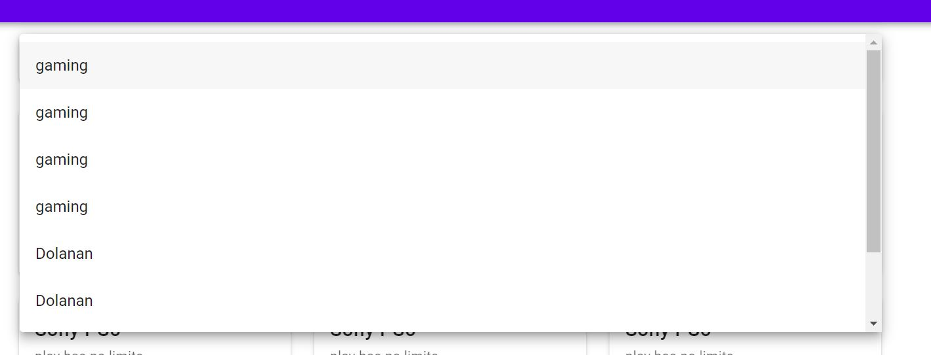

## user select more than 1 category

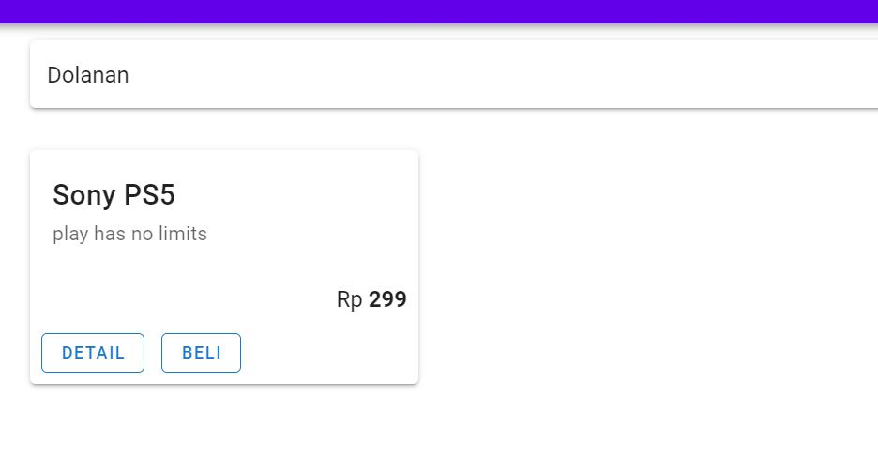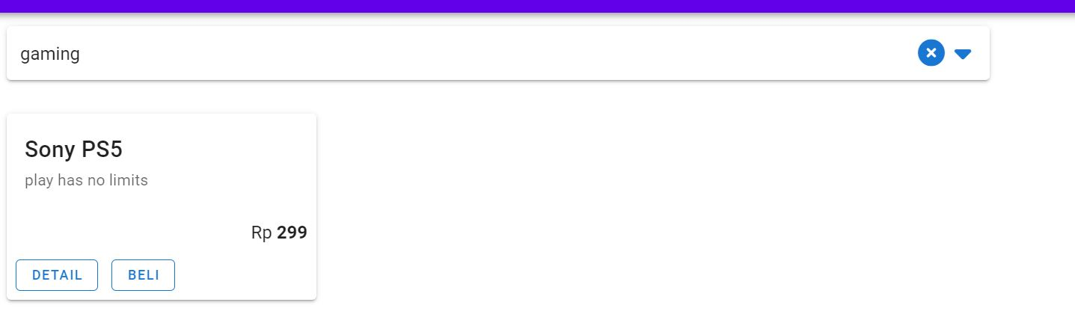

## user select clear category

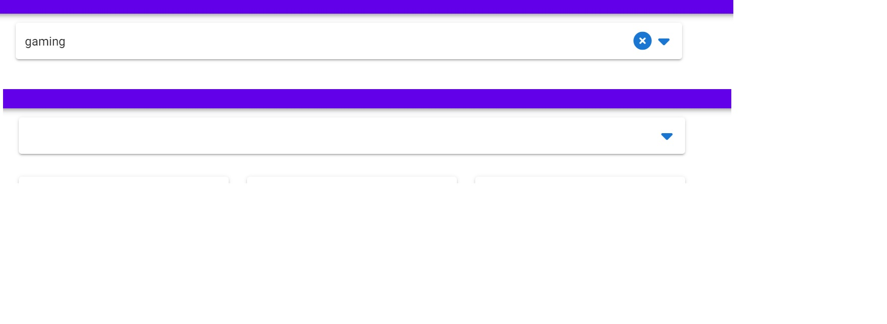

# check product functionality

## user click view product detail

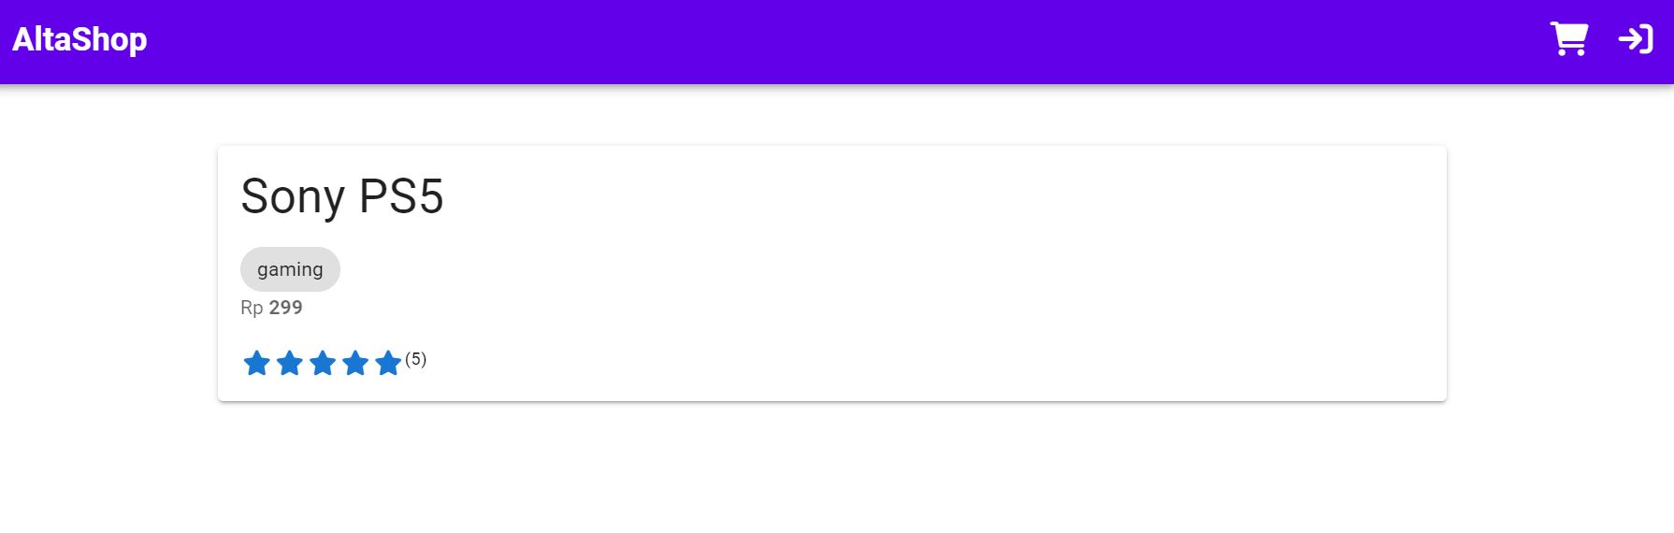

## user click category on detail page

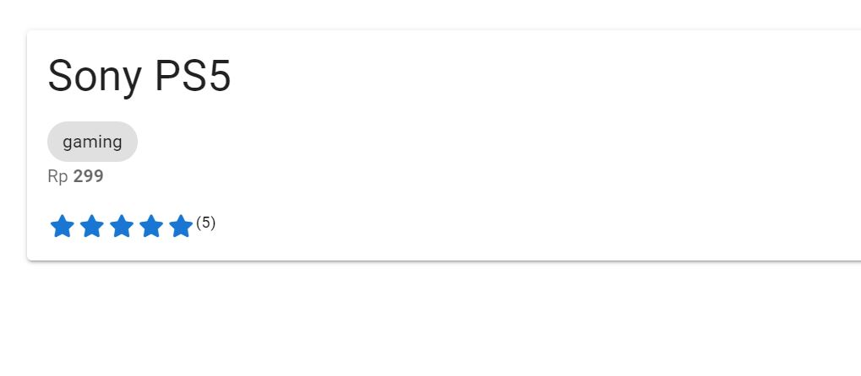

## user click rating on detail page



## user click beli button

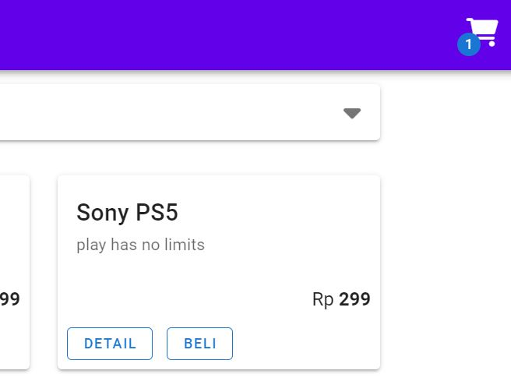

## user choose more than 1 beli button on the same product

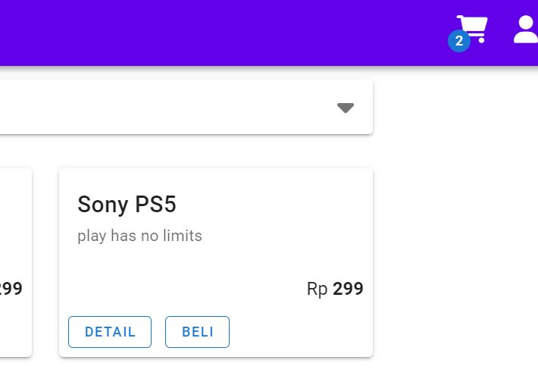

## user click beli button on another product

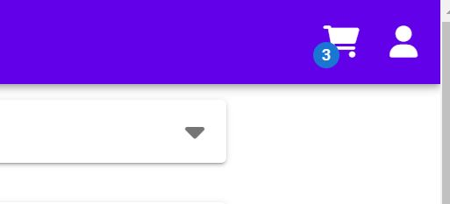

# check cart functionality

## user check view cart page

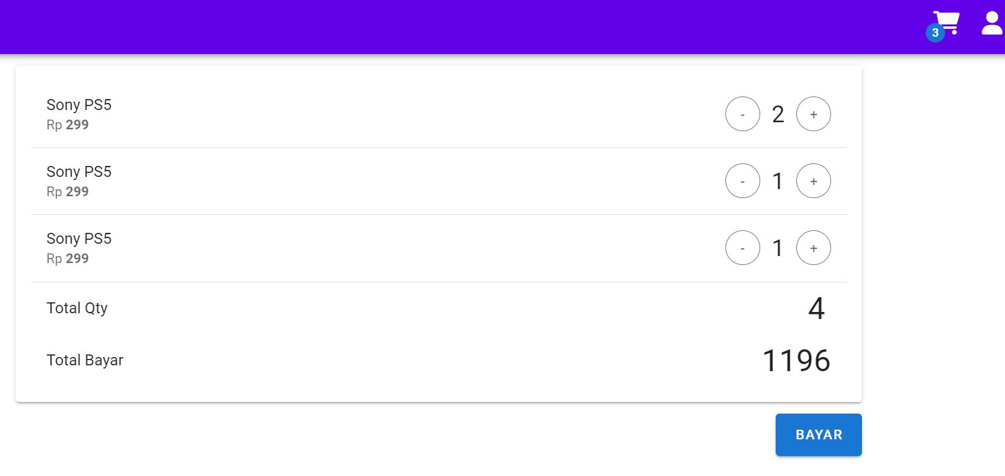

## user check - button

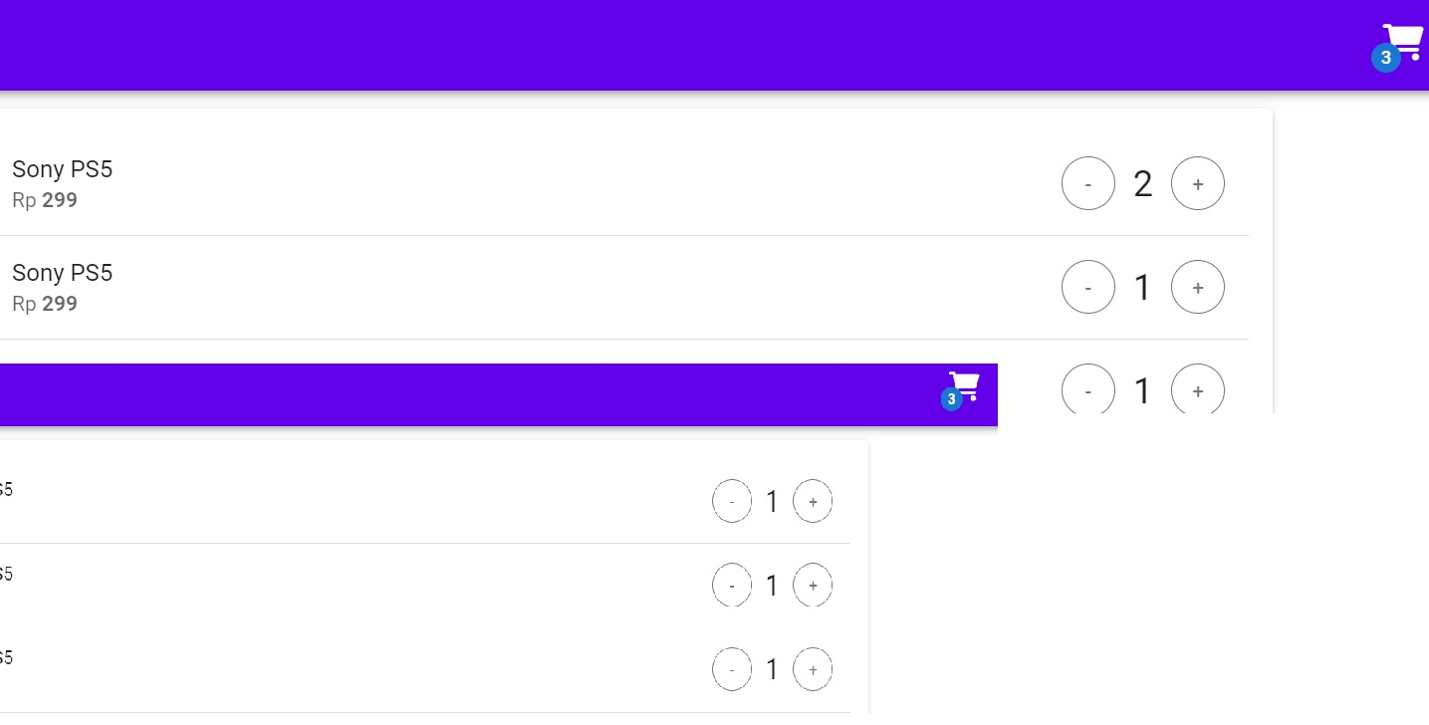

## user check + button

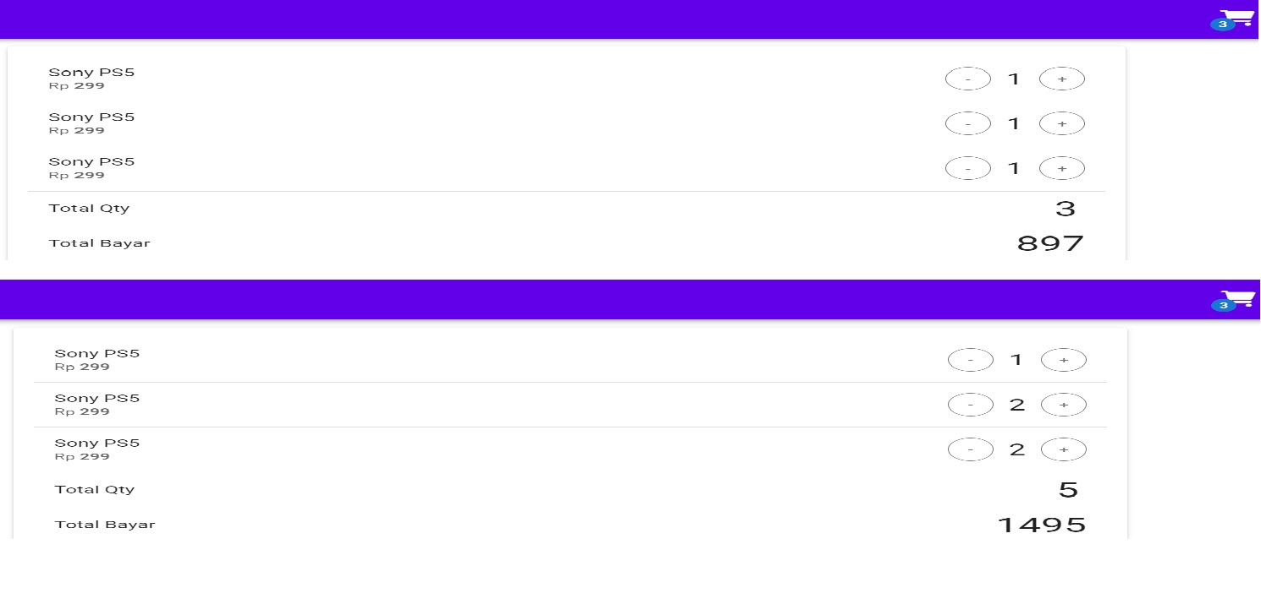

## user check bayar button

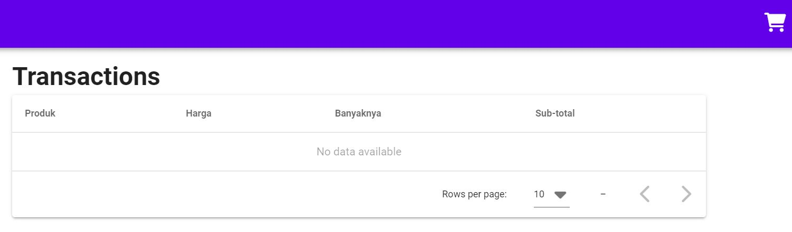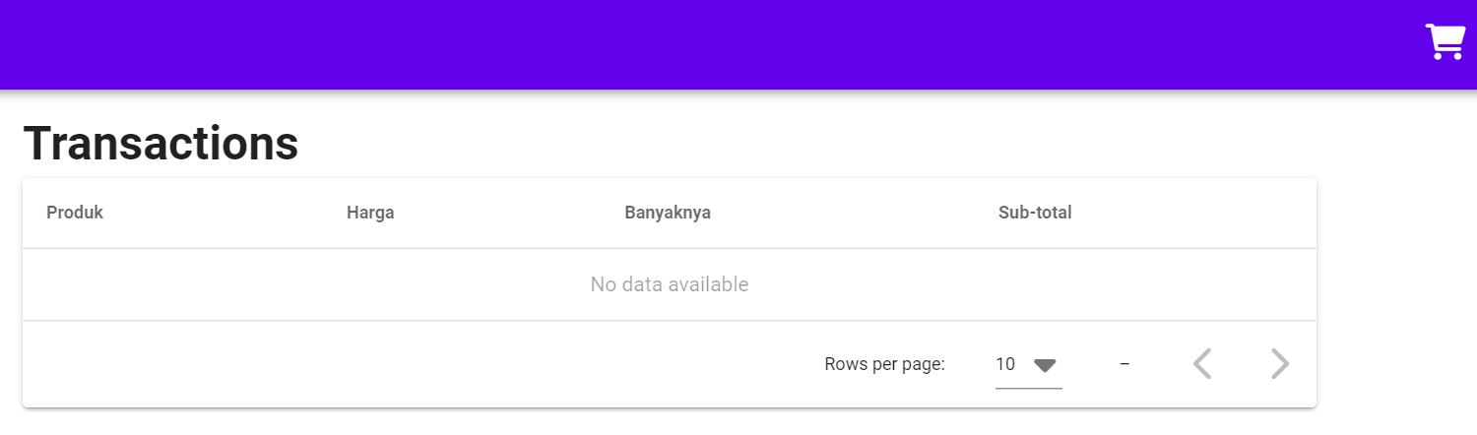

# check account functionality

## user check transaksi menu

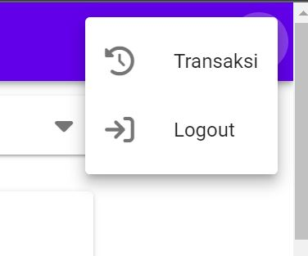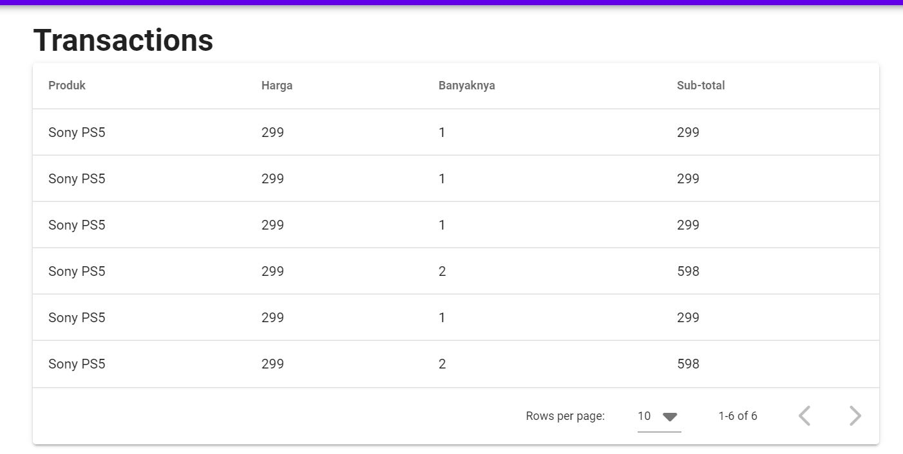

## user check logout menu

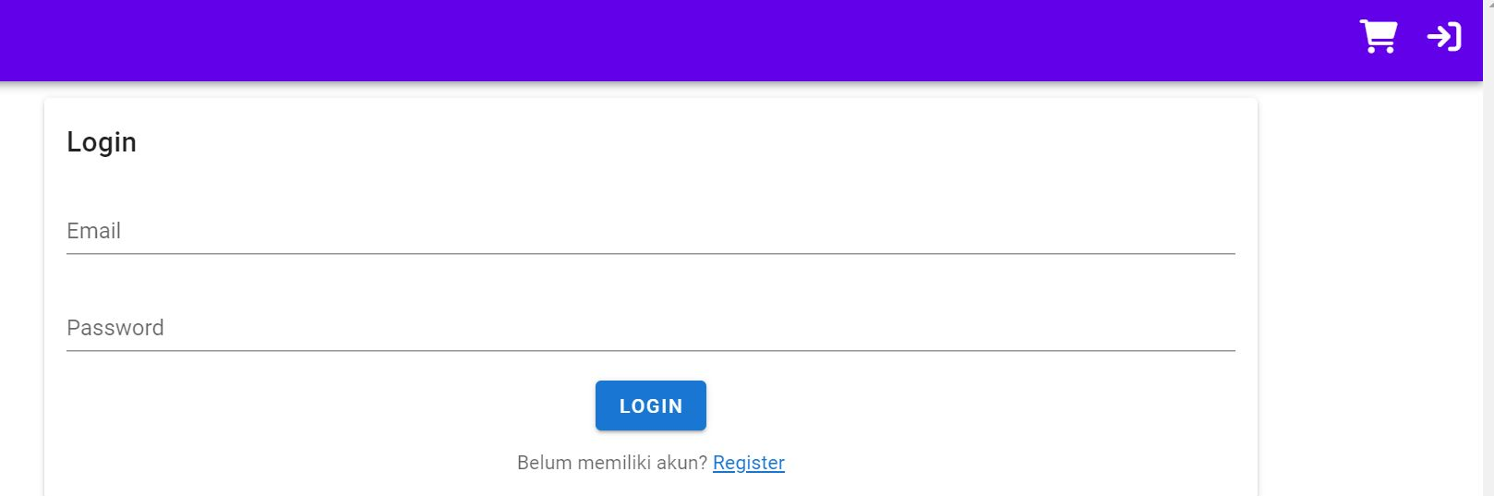

# check transactions page

## user check asc and desc on product, harga, banyaknya and sub-total fields

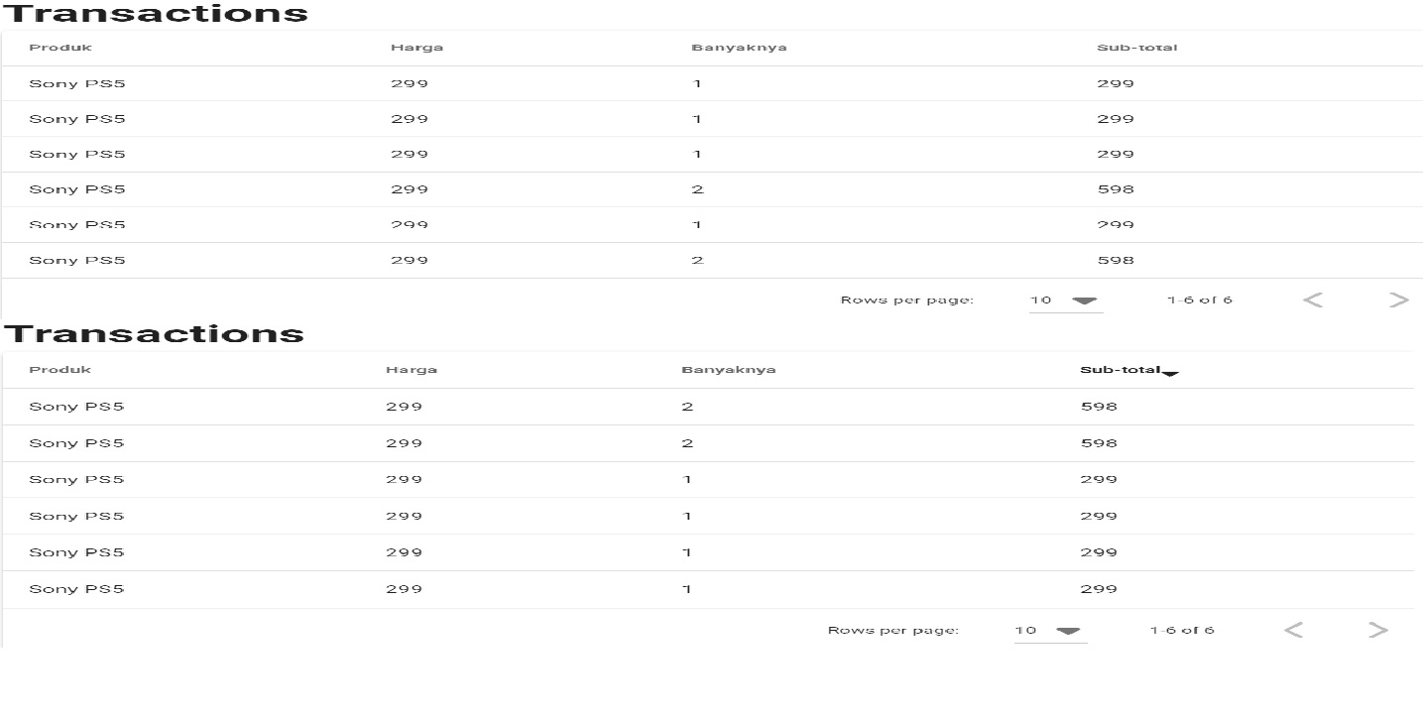

## user check change row per page

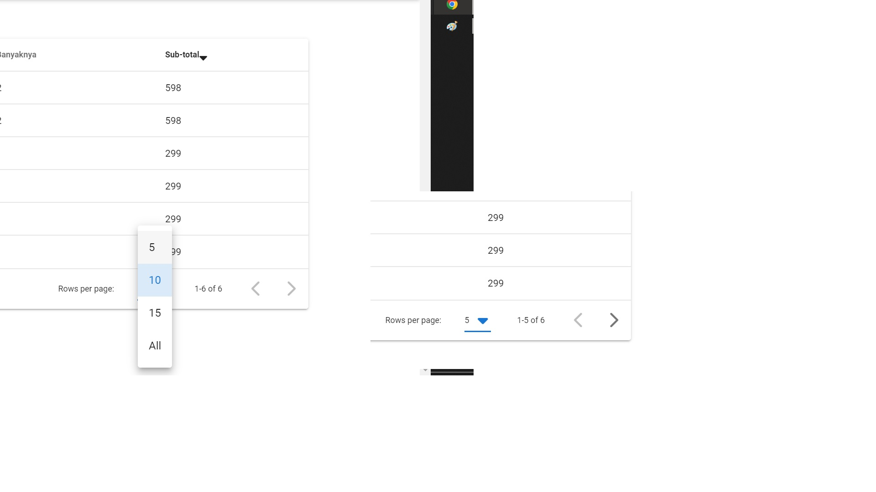

## user check next and previous page button

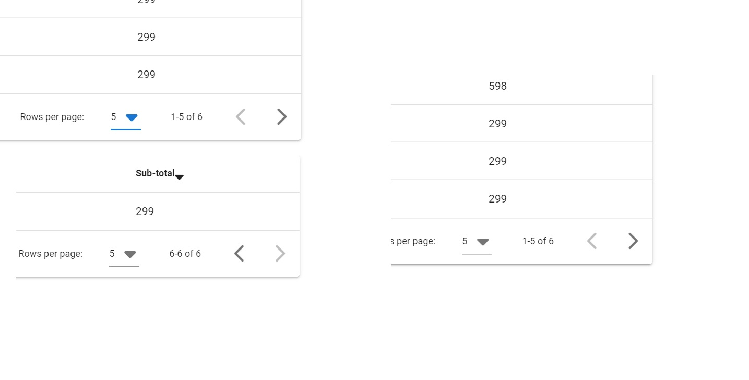

# check homepage functionality

## user check altashop homepage

